# Arrhythmia Detection using ResNet model

# (3 class- 10 Fold Cross Validation Confusion Matrix)

This depicts that data is divided into 10 parts, out of which 9 parts are used to train and validate the model, While the 1 left out part(test set-unseen to the model completely) is used to check final accuracy.

Fold 1 – 89% Fold 2 – 92%

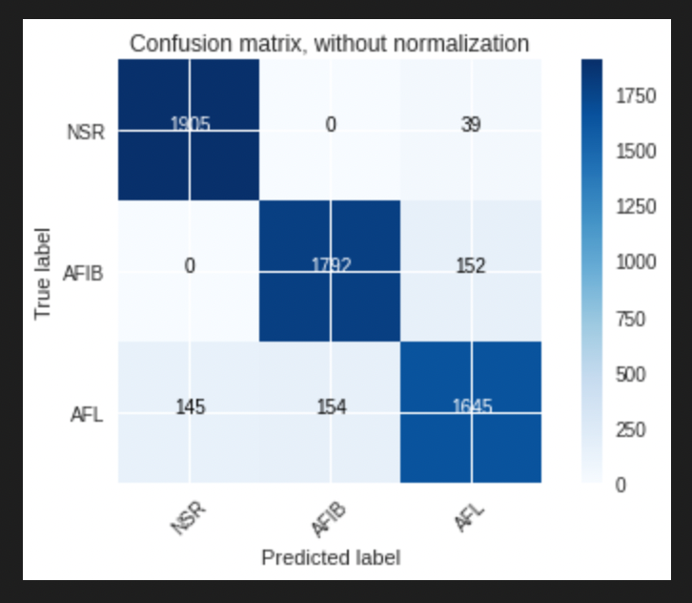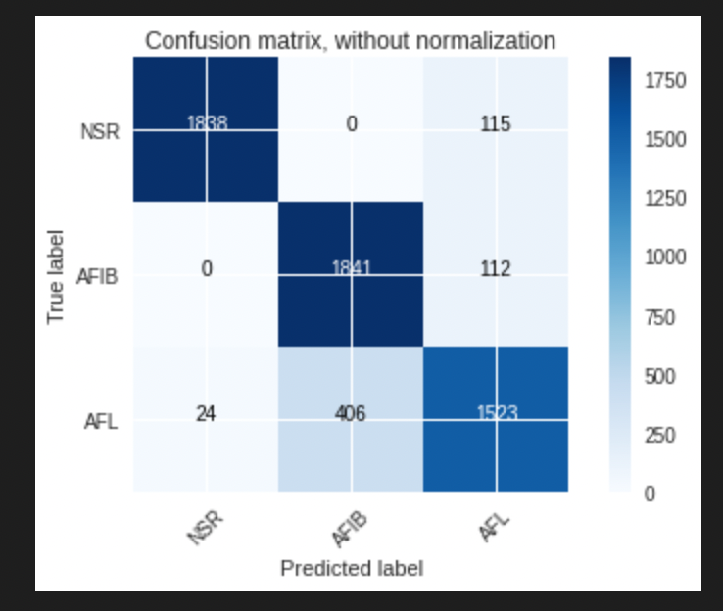

Fold 3 – 88% Fold 4 – 91%

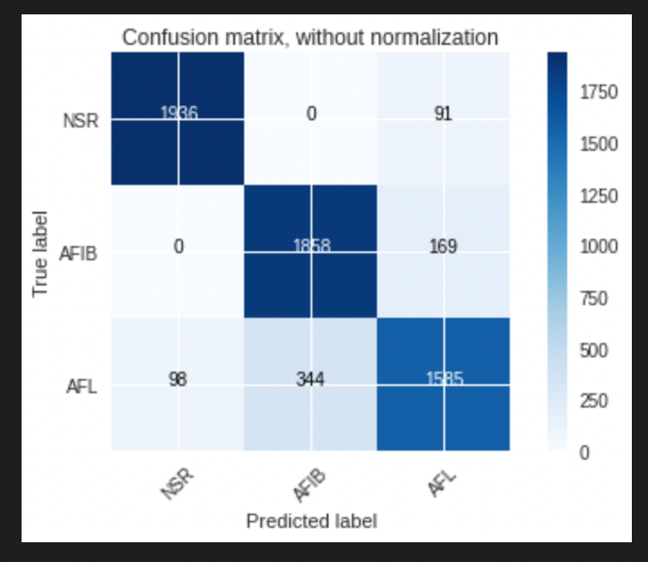

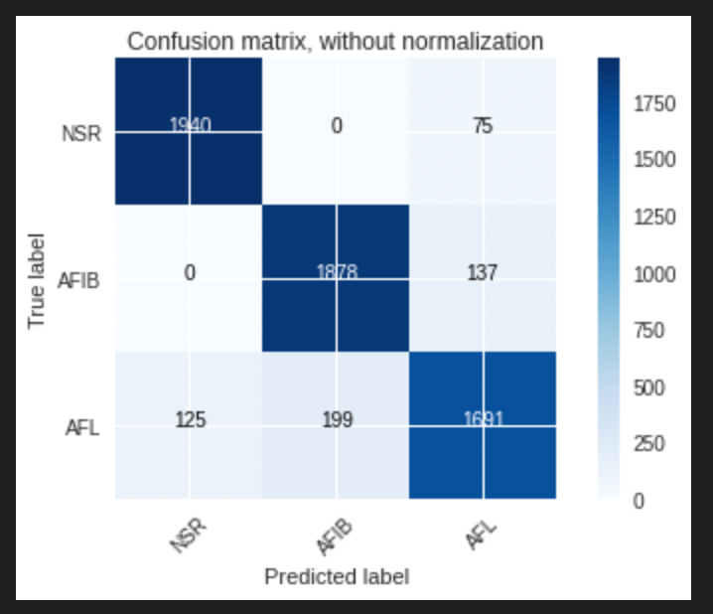

Fold 5 - 89% Fold 6 – 87%

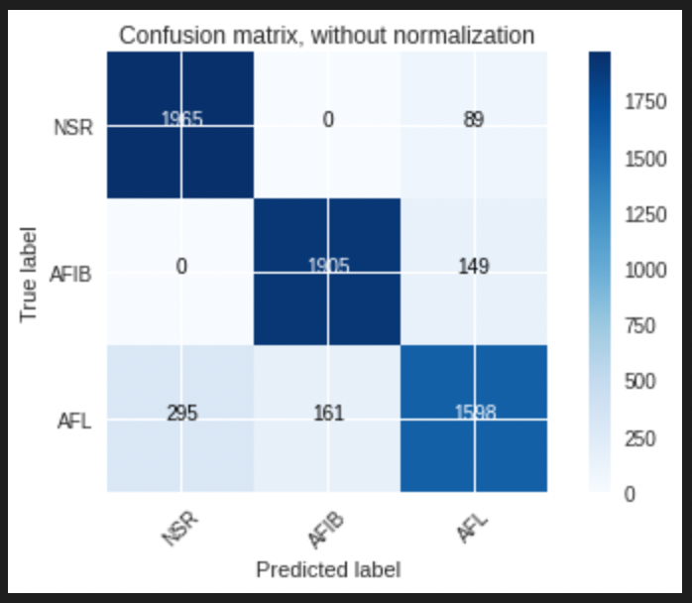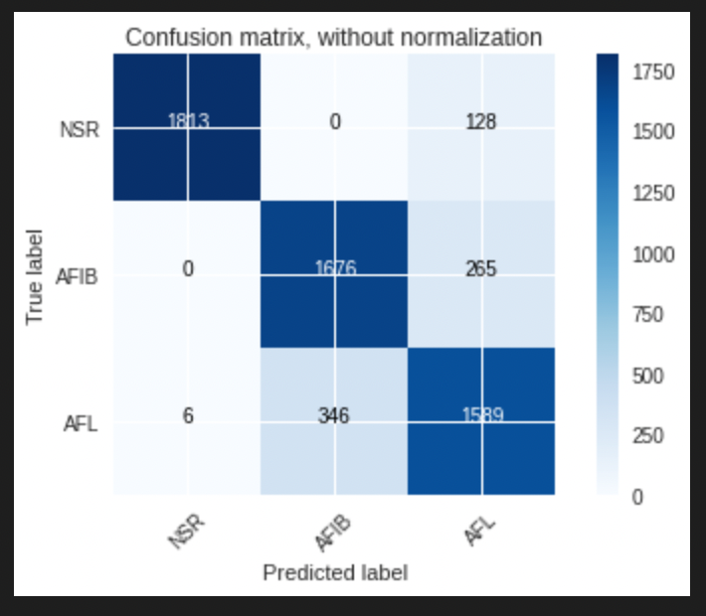

Fold 7 - 91% Fold 8 – 93%

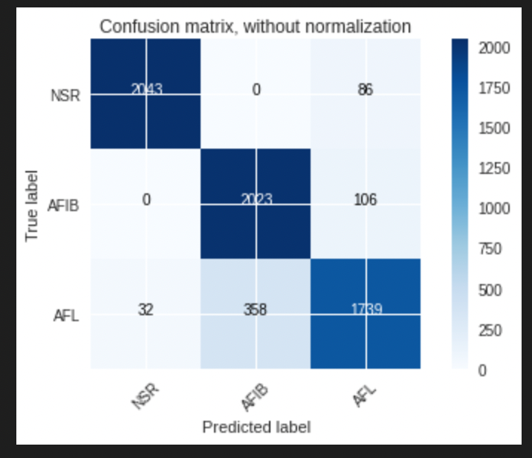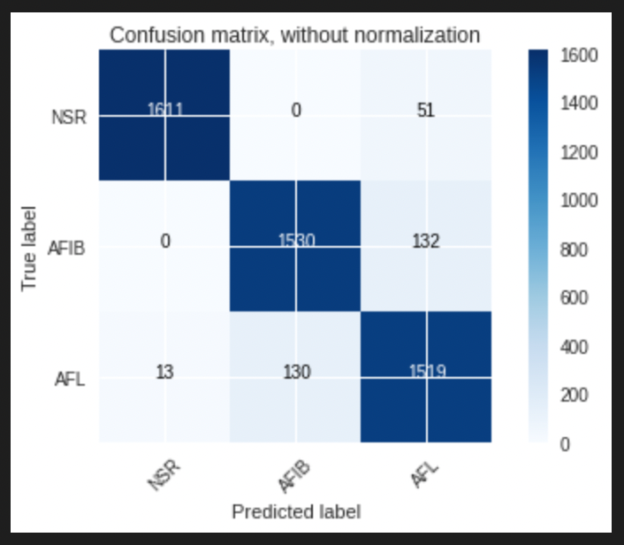

Fold 9 - 89% Fold 10 – 88%

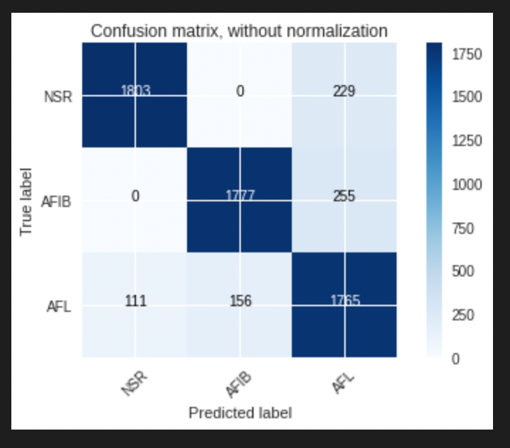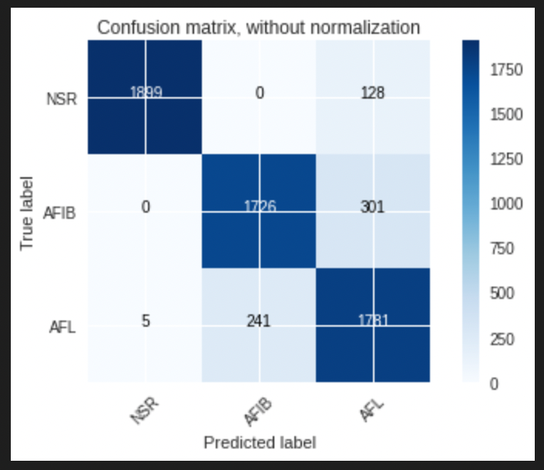

Final Accuracy across 10 fols: [89.0, 92.0, 88.0, 91.0, 89.0, 87.0, 91.0, 93.0, 89.0, 88.0]